RP001RR – POLICY - MAINTENANCE MANAGEMENT (REDRABBIT)
[Company Name] utilizes RedRabbit for the effective management and resolution of all reported or identified maintenance matters pertaining to the rental properties that we are mandated to manage and that need to be attended to and resolved.

All new personnel are required to familiarize themselves with RedRabbit by watching and studying all the available training videos.

Maintenance Resolution Workflow

The following diagram illustrates the workflow employed within RedRabbit to achieve the effective resolution and management of rental property maintenance:

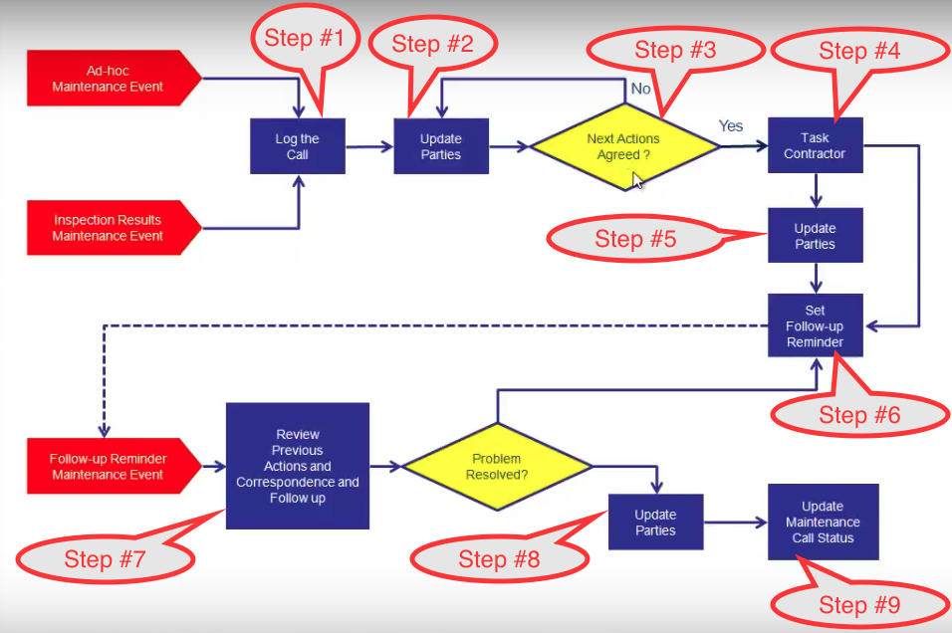

Policy, Procedures & Service Level Standards

Company Policy and Procedure requires that our maintenance management service and all associated actions adhere to the following service level standards (with reference to the RedRabbit workflow diagram):

- Log the Call/Issue (Step #1)
A maintenance ticked must be logged for all reported / identified maintenance issues within the following time frames:
  - Urgent: 1 hour
  - Other: 1 business day

- Notify Tenant that maintenance has been logged (Step #2)
  - Tenant/s must be notified immediately (as part of step #1) by SMS and email that a maintenance ticket has been logged

- Request Authority from Landlord (Step/s #2 & 3) within the following timeframes:
  - Urgent: 1 hour
  - Other: 1 business day

- Landlord instructions / authority MUST be obtained in writing – in the case of URGENT maintenance this can be confirmed by email through RedRabbit post-actioning of required actions

- Task Contractor (Step #4)
  - Urgent: 1 hour
  - Other: 1 business day

- Managing Unresolved Maintenance Tickets (Steps #4-9)
  - All actions taken MUST be actioned through and/or logged in RedRabbit
  - After all actions, a follow up reminder must be set as follows:
    - Urgent: Daily
    - Other: For a suitable date
  - The follow up reminder dashboard must be cleared daily by doing the following:
    - Follow up with contractor/s / tenant/s / landlord/s, as relevant
    - Document the actions taken on the ticket and note updates / progress
    - Update tenant/s / landlord/s / contractor/s as relevant
    - Set new follow up date

- Closing Resolved Maintenance Tickets (Step #9)
  - Invoices to be forwarded to landlord/s with CC to accounts within 1 business day of receipt
  - Enter Close Date immediately after forwarding invoice

Management Reporting

The status of maintenance management for each portfolio is included in the weekly portfolio health report (PF007).

Maintenance Ticket Dashboard

Maintenance Ticket Overview
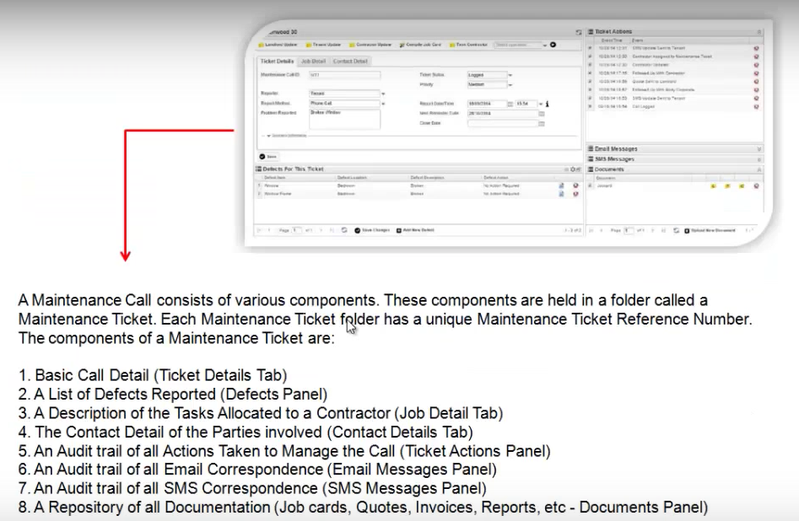

- All actions taken are logged in Actions Audit Trail – this must be used for all actions taken – also include appropriate notes. This allows other users to follow up and appraise themselves of the situation if necessary and will be used to ensure compliance with company policy and service level standards and to follow up/determine validity of complaints and corrective action/s
- Correspondence Trail – all email messages & SMS messages are logged - to be used to ensure adherence with company policy

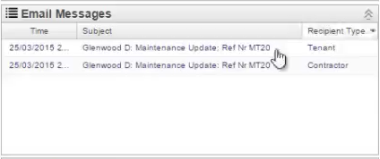
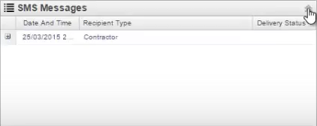
- Maintenance calls have a priority – determined by the nature of the defect/s and determines the follow up frequency in line with company policy

Maintenance Ticket Details
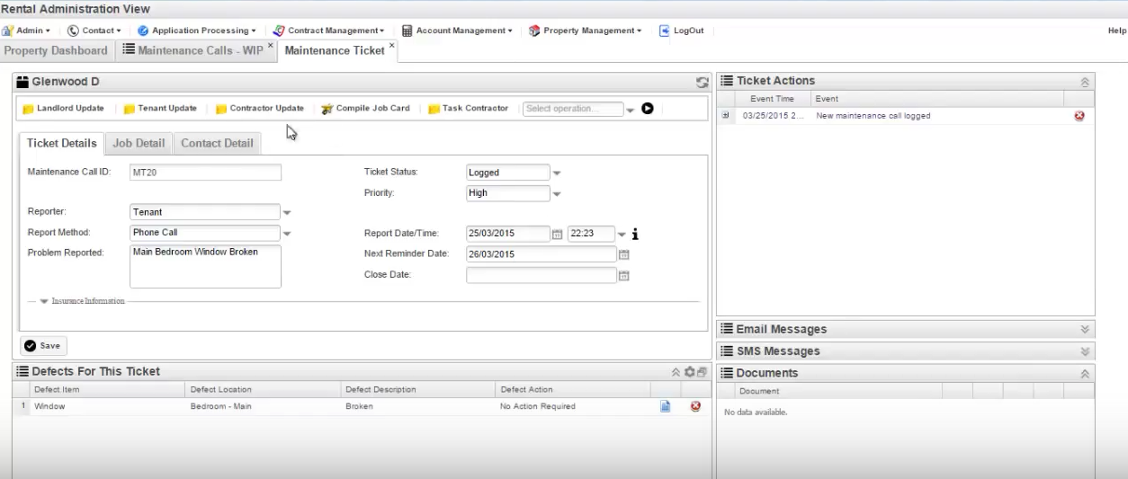

Job Detail

Maintenance Ticket Workflow

Logging Maintenance Calls

Step #1 – Log the Call & Create Maintenance Ticket
#1A - Log a new maintenance call
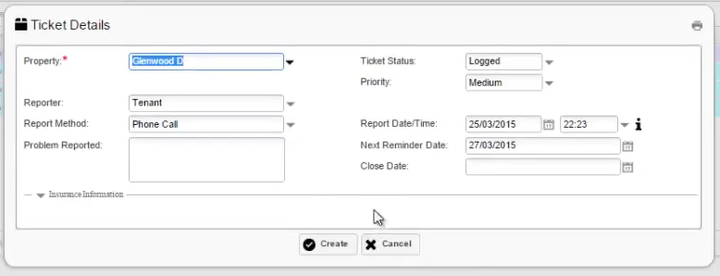
Note: Maintenance tickets can also be created direct from defects noted during inspections

Maintenance Ticket Priorities
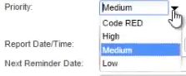

Next Reminder Date
Determined by priority of the maintenance ticket

#1B – Define defect/s
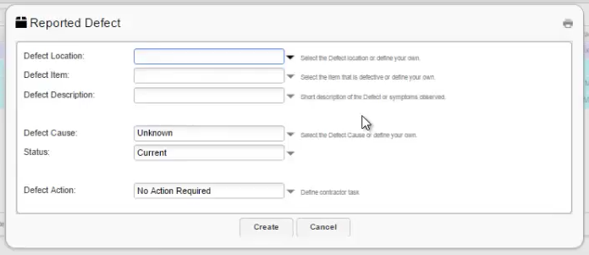

Resolving Maintenance Calls

Step #2 – Update Parties
- Tenant
  - Confirm with tenant that call has been logged & action taken
  - Seek further details/pics, if necessary
- Landlord
  - Notify Landlord of logged call & seek instructions

Step #3 – Agree Action/s
- Landlord Follow Up – update status & note landlord instructions
- Update defect action to be taken in maintenance ticket
  - Defect Action options
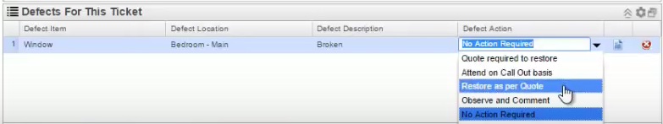

Step #4 –Task Contractor with JobCard
- Can use the same maintenance ticked to send to multiple contractors for quotes
- Defect Actions needs to be set
- Need to include instruction/s for contractor
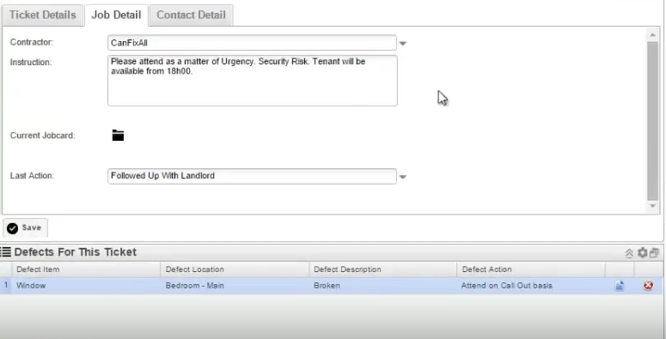

- Compile JobCard
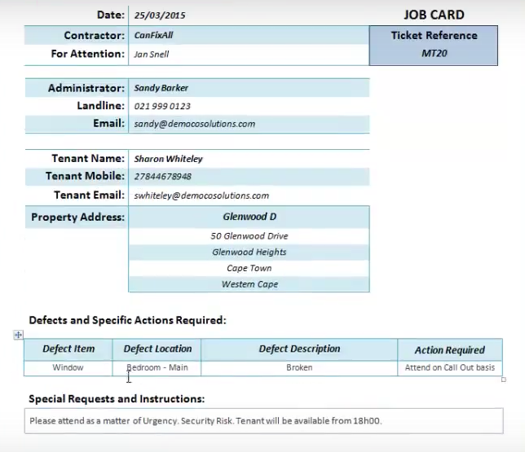
Note: JobCard includes tenant contact details

- Task Contractor
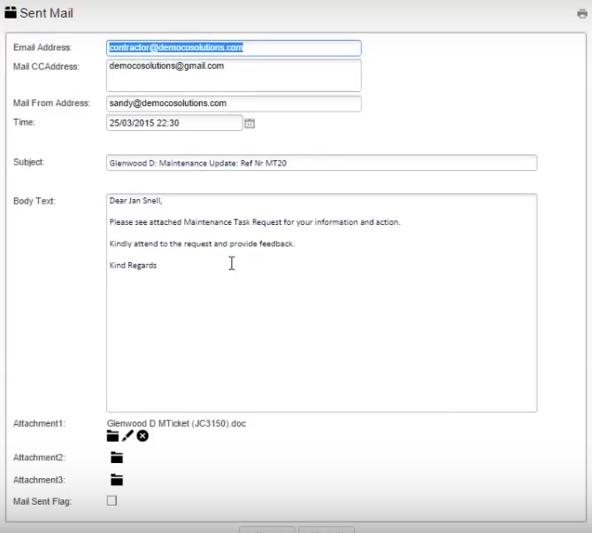

- If urgent, can SMS contractor
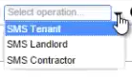
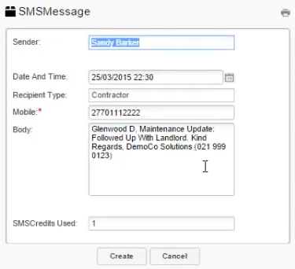

- Update Next Reminder Date

Step #5 – Update Parties
- Tenant – click on Tenant Update button
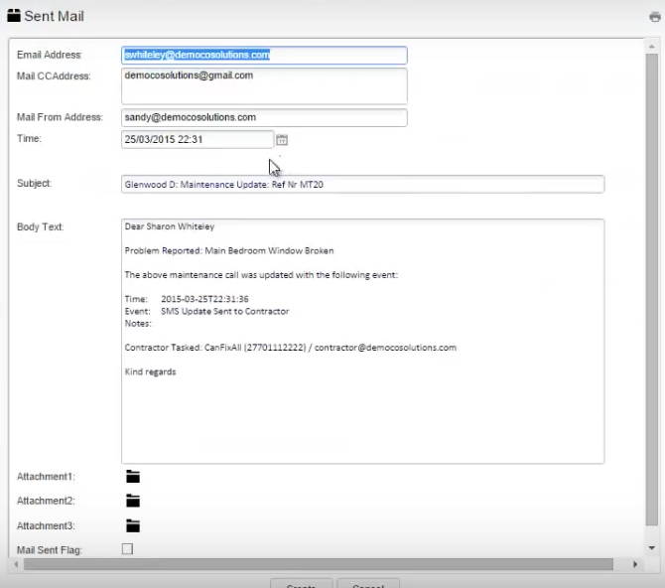
Note: Can edit and add Notes if necessary

- Landlord
- Contractor

- Update Next Reminder Date

Step #6 – Follow up Reminder
- Check maintenance reminders every morning – company policy
- Maintenance reminders – maintenance WIP
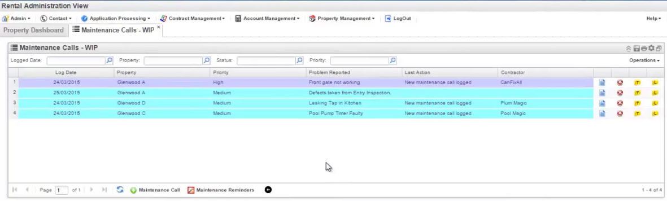

Step #7 – Review/Follow Up
- Use the (Landlord Update), (Tenant Update) and (Contractor Update) functionality in RPMS to ensure that update emails/SMSs are logged for future reference
- Tenant – check with tenant if defect/s have been attended to satisfactorily
- Contractor – follow up with contractor if defect not rectified yet
- Landlord – update landlord if necessary
- All updates to be logged by updating Last Actions Taken files in maintenance ticket

Maintenance Defect Resolved

Step #8 – Update Parties
- Tenant – confirm that work has been completed satisfactorily
- Landlord – inform landlord that problem is resolved
- Contractor – inform contractor who to email invoice to
- Instructions/important feedback from parties should be converted to PDF and uploaded as documents into maintenance ticket

Step #9 – Job Completed
- Update maintenance ticket status to Resolved when problem has been resolved
- Defect status automatically updated to Fixed when call is marked as completed
- Received invoices need to be imported into the completed maintenance call ticket
- Update maintenance ticket status to Closed when invoice is received and sent to landlord for info (cc accounts)

